VS Code

Short Cut Keys
- Convert selection to uppercase – Alt+Shift+x *
- Convert selection to lowercase – Alt+Shift+y *
- Save Source – Ctrl+s, then select the correct command and press enter
- Compile Alt+e, then arrow over one and press enter.
- Comment or Un-comment line or block of selected code, fixed format only, Ctrl+/, toggle between comment/un-comment
- Undo Ctrl+z
- Copy Ctrl+c
- Paste Ctrl+v (display clip board history and paste from it, Windows key+v)
- Cut Ctrl+x
- Open a member without browsing Ctrl+Alt+P, type in the information, it gives examples and tries to auto fill.
- Duplicate line Shift+Alt+Down Arrow
- Open same program in split screen Ctrl+\
- Switch tabs, Ctrl+Tab
- Jump to a subroutine, procedure or field definition F12
- Go to top Ctrl+Home
- Go to Bottom Ctrl+End
- See all shortcuts Ctrl+k then Ctrl +S
- Move back/forward to last position Alt+Left, Alt+Right. For example, if you use the Outline to go to a subroutine and you want to go back to where you were before that use Alt+Left.
- Format Alt+Shift+F, lines up tabbing
- Refactor Ctrl+Shift+R (don’t know what this does yet, doesn’t seem to work like rdi)
- Trim trailing whitespace, does it by default when save and re-open, can be done manually using Ctrl+y Ctrl+x, you do not have to let up on Ctrl between them.
- Block select, put your cursor at the start of the block, hold shift + alt and click at the end of the block. This also makes your cursor the size of the selection, press escape to end that.
* = Must be manually set up, can be any key combination.

Cool Features
It is free, unlike RDI.
The editor is a general editor with a lot of plugin support for many different languages. This means it can be used to write RPG code, Python, HTML, CSS, Ruby, XML, SQL, JSON, Etc.
Eliminates the need for GUI query because it includes that feature.
Allows running an SQL command from within an SQL source member.
Convert to free works for H, D and F specs. It also replaces key lists.
Data Base Explorer allows viewing and querying of DB objects, regenerates source code for triggers.
Has a plugin for Git hubs copilot program. This provides an AI programming assistant that automates a lot of common coding. Not sure how well it will work with RPG, but being AI, it will only get better with use.

Installation and Setup
Install VS Code. Just do a web search VS Code download.
Install the plugin, IBM I Developer Pack. Click the plugin icon on the left side bar. It looks like this:
 Yours probably won’t have the 1 on it yet.
This displays the plug-in tool bar, there is a search bar at the top, just enter IBM I Developer Pack. Find it and click the install button.
This pack installs 13 plugins that together provide all the tools needs for coding on an IBM in RPG, CL, C and Cobol.

Setup a Connection to Your Server
There was wizard for this when the pack was first installed, I cannot do it now to document it.

Fixing CCSID 65535 issue
Click the connection name at the bottom of the screen to open the properties, Click the source code tab and enter 37 in the Source file CCSID. This will really mess things up if your system uses a different CCSID, but if the system was set up to use 65535 and you really are in the US this will fix it.
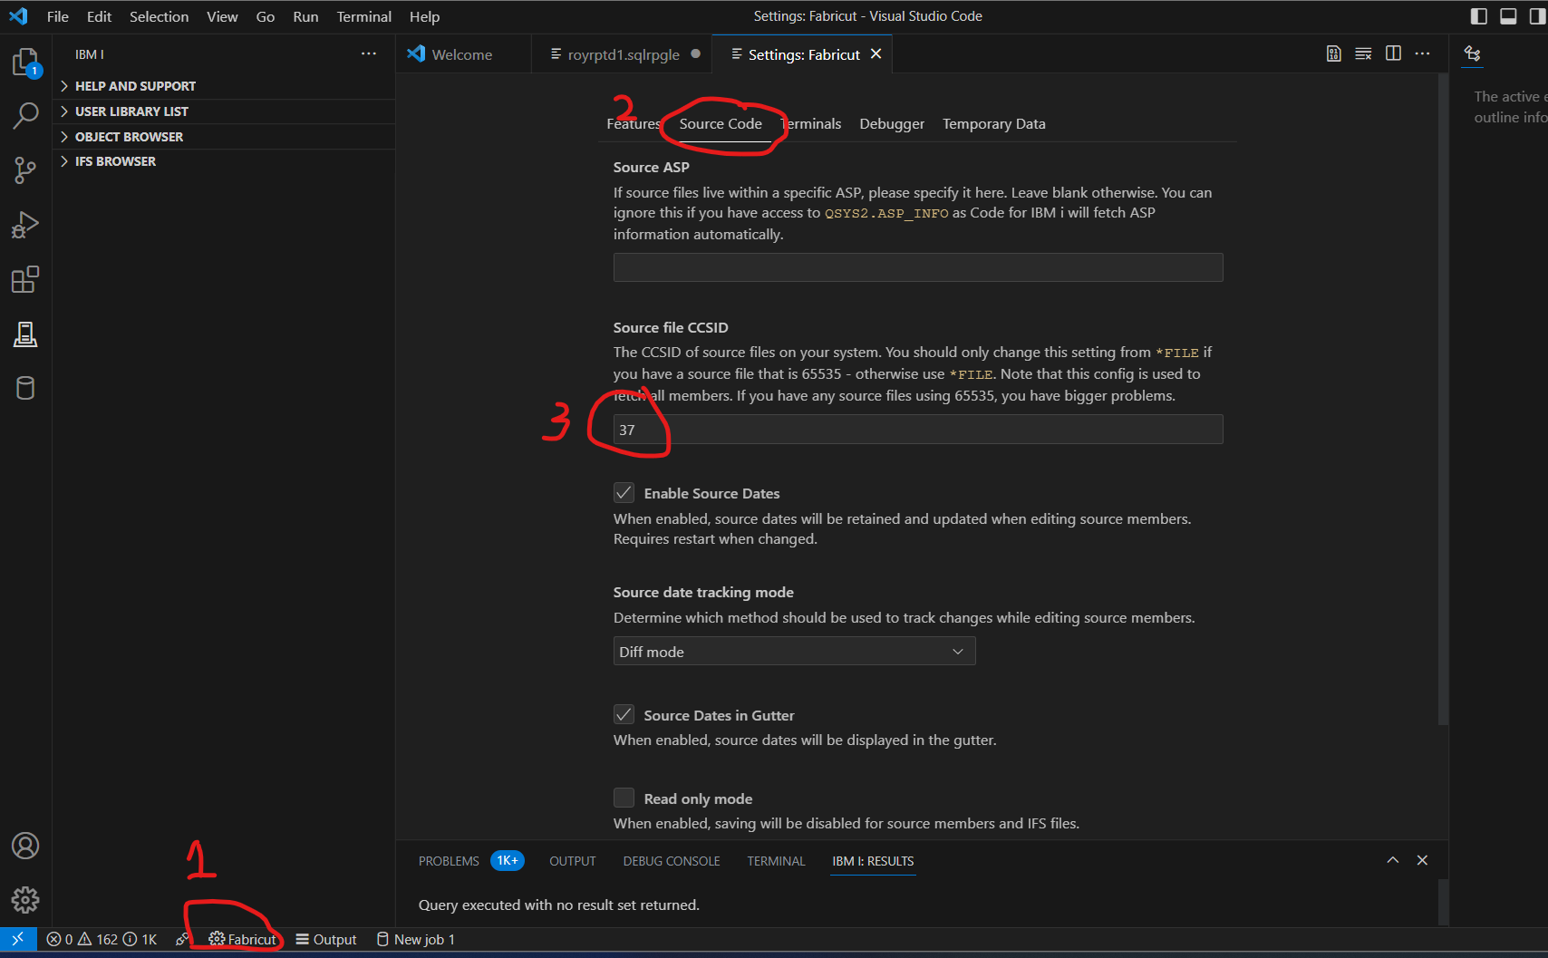

Fix Source Date Change Issue
On the same settings screen, Check the box Highlighted below to enable the Source Date option. If not, when a source is opened, it will reset all the source change dates to ZERO.
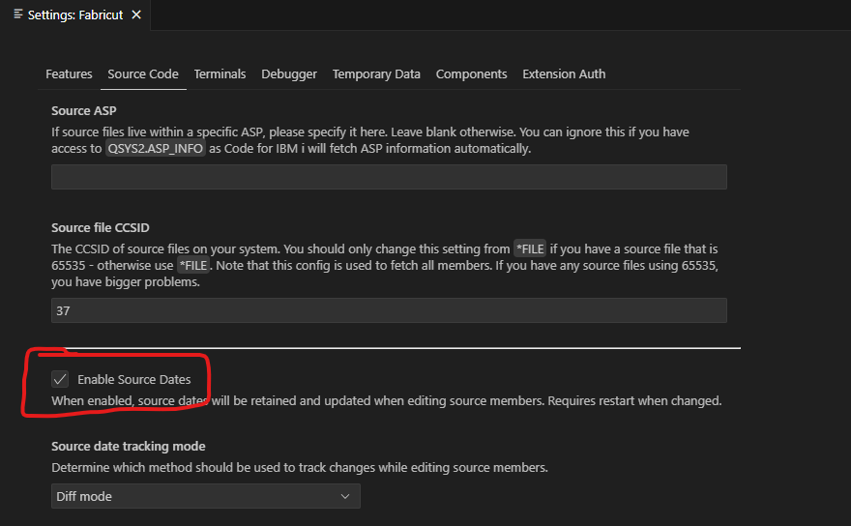

Fixed Format Helper
To turn on Fixed format helper, go to the extensions tab, click the settings cog next to the RPGLE extension and click settings. Then click the check box that provides column assist for fixed format.
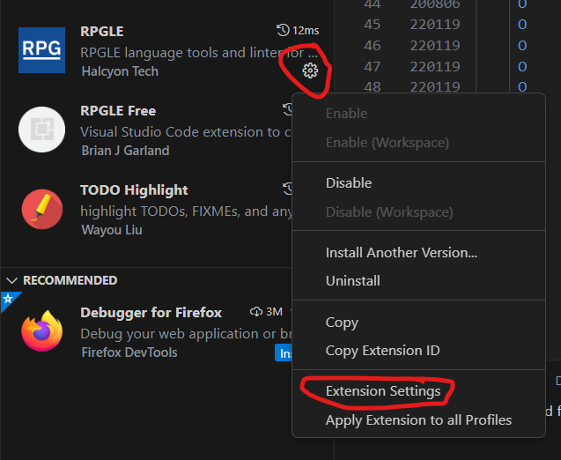

New File Associations
Since we use member types like SQLTABLE and SQLVIEW, the system does automatically associate these with type SQL. The first time you open one you will need to associate it with the correct file type. This is done using “Ctrl+k m” It will open a prompt at the top, select configure file association, then search for SQL and select it. Now each time you open that file type it will associate it as an SQL file and will color code it correctly. This will also allow you to use Ctrl+r to run any SQL statements in the file.

Setting Up Custom Keyboard Shortcuts
This is going to show how to setup the Alt+Shift+x used to make the highlighted text upper case, the same steps can be used for other functions.
Go to file, preferences, keyboard shortcuts. Search for “editor action transform to upper”, this should get you to one entry. Right click the entry and select add key binding. This will pop up an entry prompt to record the key binding, just press the keys you want to use for the shortcut. In this case we also want to populate the when clause, so right click the entry again and select Change When Expression. Enter editorTextFocus and press enter.
It should look like this:
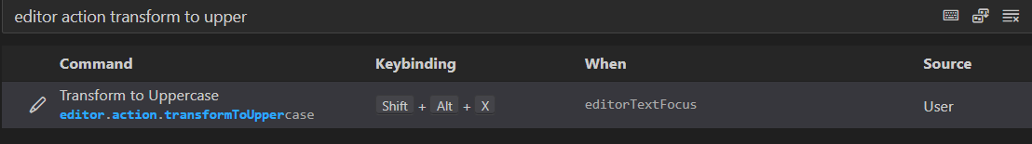

Setup RPG Linting/Formatting
Linting and formatting options are stored at the library level and must be set up before they work. To set them up, open the command pallet with CtrlShift+p, and search for RPGLE: open RPGLE lint configuration. This will open a JSON file with the default options.
I suggest changing the indent to 2 and stringLiteralDupe to false. Or you can replace the entire file with the contents below which will also add auto capitalization on common commands. Save the file and close it. You then must close any open RPG source files and reopen them to get it to work.
This is saved on the IBM I in a new source file created in each library called VSCODE. So, this needs to be re-done for each library you develop in. This forces each program to use the same set of rules within a library.
These options only work for **free programs. Not much more development will be done for fixed format programming as everyone is expected to switch to **free.

Case Linting Configuration:
{
"indent": 2,
"PrototypeCheck": true,
"NoOCCURS": true,
"NoSELECTAll": true,
"UppercaseConstants": true,
"IncorrectVariableCase": true,
"StringLiteralDupe": false,
"NoSQLJoins": false,
"PrettyComments": true,
"NoGlobalSubroutines": true,
"NoExternalTo": [
"QCMD",
"QP2TERM",
"QSH",
"SYSTEM",
"QCMDEXC"
],
"SpecificCasing": [
{"operation": "*bif", "expected": "*lower"},
{"operation": "*no", "expected": "*No"},
{"operation": "*nodebugio", "expected": "*NoDebugIO"},
{"operation": "*noshowcpy", "expected": "*NoShowCpy"},
{"operation": "*srcstmt", "expected": "*SrcStmt"},
{"operation": "**free", "expected": "**Free"},
{"operation": "/copy", "expected": "/Copy"},
{"operation": "/include", "expected": "/Include"},
{"operation": "alias", "expected": "Alias"},
{"operation": "always", "expected": "Always"},
{"operation": "as", "expected": "as"},
{"operation": "allocate", "expected": "Allocate"},
{"operation": "begsr", "expected": "BegSr"},
{"operation": "case", "expected": "Case"},
{"operation": "bnddir", "expected": "BndDir"},
{"operation": "by", "expected": "by"},
{"operation": "char", "expected": "Char"},
{"operation": "clear", "expected": "Clear"},
{"operation": "close", "expected": "Close"},
{"operation": "column", "expected": "Column"},
{"operation": "ctl-opt", "expected": "Ctl-Opt"},
{"operation": "create", "expected": "Create"},
{"operation": "cast", "expected": "Cast"},
{"operation": "chain", "expected": "Chain"},
{"operation": "cursor", "expected": "Cursor"},
{"operation": "commit", "expected": "Commit"},
{"operation": "count", "expected": "Count"},
{"operation": "concat", "expected": "Concat"},
{"operation": "datedit", "expected": "datEdit"},
{"operation": "dcl-c", "expected": "Dcl-C"},
{"operation": "dcl-ds", "expected": "Dcl-Ds"},
{"operation": "dcl-f", "expected": "Dcl-F"},
{"operation": "dcl-pi", "expected": "Dcl-Pi"},
{"operation": "dcl-pr", "expected": "Dcl-Pr"},
{"operation": "dcl-proc", "expected": "Dcl-Proc"},
{"operation": "dcl-s", "expected": "Dcl-S"},
{"operation": "deallocate", "expected": "Deallocate"},
{"operation": "debug", "expected": "debug"},
{"operation": "declare", "expected": "Declare"},
{"operation": "default", "expected": "Default"},
{"operation": "definition", "expected": "Definition"},
{"operation": "descriptor", "expected": "Descriptor"},
{"operation": "delete", "expected": "Delete"},
{"operation": "describe", "expected": "Describe"},
{"operation": "dftactgrp", "expected": "DftActGrp"},
{"operation": "distinct", "expected": "Distinct"},
{"operation": "diagnostics", "expected": "Diagnostics"},
{"operation": "dow", "expected": "DoW"},
{"operation": "dou", "expected": "DoU"},
{"operation": "drop", "expected": "Drop"},
{"operation": "end", "expected": "End"},
{"operation": "end-ds", "expected": "End-Ds"},
{"operation": "end-pi", "expected": "End-Pi"},
{"operation": "end-pr", "expected": "End-Pr"},
{"operation": "end-proc", "expected": "End-Proc"},
{"operation": "enddo", "expected": "EndDo"},
{"operation": "endfor", "expected": "EndFor"},
{"operation": "endif", "expected": "EndIf"},
{"operation": "endmon", "expected": "EndMon"},
{"operation": "endsr", "expected": "EndSr"},
{"operation": "else", "expected": "Else"},
{"operation": "elseif", "expected": "ElseIf"},
{"operation": "exec", "expected": "Exec"},
{"operation": "execute", "expected": "Execute"},
{"operation": "exsr", "expected": "ExSr"},
{"operation": "exfmt", "expected": "Exfmt"},
{"operation": "fetch", "expected": "Fetch"},
{"operation": "first", "expected": "First"},
{"operation": "for", "expected": "For"},
{"operation": "from", "expected": "From"},
{"operation": "generated", "expected": "Generated"},
{"operation": "get", "expected": "Get"},
{"operation": "grant", "expected": "Grant"},
{"operation": "identity", "expected": "Identity"},
{"operation": "if", "expected": "If"},
{"operation": "immediate", "expected": "Immediate"},
{"operation": "increment", "expected": "Increment"},
{"operation": "insert", "expected": "Insert"},
{"operation": "integer", "expected": "Integer"},
{"operation": "into", "expected": "Into"},
{"operation": "inz", "expected": "Inz"},
{"operation": "is", "expected": "is"},
{"operation": "join", "expected": "Join"},
{"operation": "key", "expected": "Key"},
{"operation": "label", "expected": "Label"},
{"operation": "leavesr", "expected": "LeaveSr"},
{"operation": "leave", "expected": "Leave"},
{"operation": "left", "expected": "Left"},
{"operation": "monitor", "expected": "Monitor"},
{"operation": "next", "expected": "Next"},
{"operation": "null", "expected": "Null"},
{"operation": "on", "expected": "on"},
{"operation": "on-error", "expected": "On-Error"},
{"operation": "only", "expected": "Only"},
{"operation": "open", "expected": "Open"},
{"operation": "option", "expected": "Option"},
{"operation": "order", "expected": "Order"},
{"operation": "prepare", "expected": "Prepare"},
{"operation": "primary", "expected": "Primary"},
{"operation": "qualified", "expected": "Qualified"},
{"operation": "quallified", "expected": "Quallified"},
{"operation": "public", "expected": "Public"},
{"operation": "rcdfmt", "expected": "RcdFmt"},
{"operation": "reset", "expected": "Reset"},
{"operation": "return", "expected": "Return"},
{"operation": "read", "expected": "Read"},
{"operation": "reade", "expected": "ReadE"},
{"operation": "readpe", "expected": "ReadPE"},
{"operation": "row", "expected": "Row"},
{"operation": "rtrim", "expected": "rtrim"},
{"operation": "select", "expected": "Select"},
{"operation": "setgt", "expected": "SetGT"},
{"operation": "setll", "expected": "SetLL"},
{"operation": "set", "expected": "Set"},
{"operation": "sql", "expected": "*upper"},
{"operation": "sqlstm", "expected": "sqlStm"},
{"operation": "sqlstate", "expected": "sqlState"},
{"operation": "start", "expected": "Start"},
{"operation": "sql", "expected": "SQL"},
{"operation": "table", "expected": "Table"},
{"operation": "template", "expected": "Template"},
{"operation": "test", "expected": "Test"},
{"operation": "text", "expected": "Text"},
{"operation": "then", "expected": "Then"},
{"operation": "to", "expected": "To"},
{"operation": "update", "expected": "Update"},
{"operation": "using", "expected": "Using"},
{"operation": "value", "expected": "Value"},
{"operation": "varchar", "expected": "Varchar"},
{"operation": "when", "expected": "When"},
{"operation": "where", "expected": "Where"},
{"operation": "with", "expected": "With"},
{"operation": "write", "expected": "Write"},
{"operation": "and", "expected": "*lower"},
{"operation": "or", "expected": "*lower"},
{"operation": "not", "expected": "*lower"}
]
}

Ruler end of line markers
It is often nice to know how far out you can enter source code. You can do this with ruler settings in VS code.
Go to File, Preference, Settings, search for ruler, click Edit in setting.json. Enter the following lines at the start of the JSON object, directly after the initial {.
"editor.rulers": [
80,
120
],

I used 80 for older source files and 120 for new source files. You can use whatever you want. This just puts a vertical line down the editor to show where the end of line is.
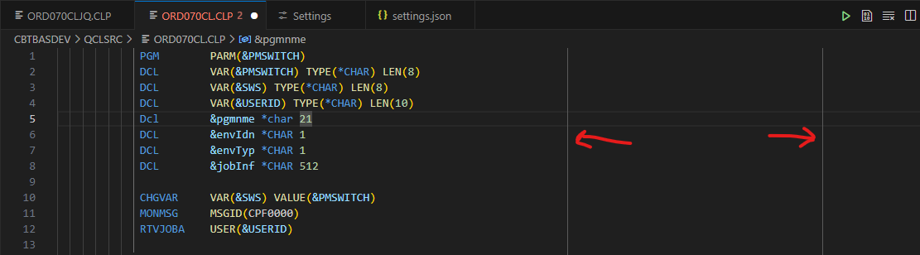

Adding Outline View
The outline view is often hard to find. Some programmers prefer it to the left of the main editor panel. To do this follow these steps:
- Open the outline view
  - Use the View menu at the top
  - Select Open View
  - Type in outline after view
  - 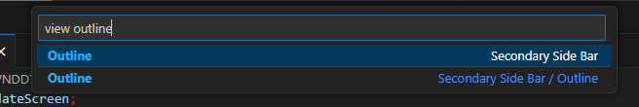
  - Click the outline option in the list, either one if there are multiple.
- By default, it opens in the left side panel. Just drag it to the right-side panel. If one does not exist it will create one when dragging it.

Format Outline View
Open an SQLRPGLE source member. Use Ctrl + , to open the settings tab. Search for outline. I unchecked the following options to see it the way I want to:
- Show arrays
- Show Booleans
- Show constants
- Show fields
- Show Files
- Show Modules
- Show Null
- Show Numbers
- Show Variables

